Batch: B1 Roll No.: 1711072

Experiment / assignment / tutorial No. 1

Grade: AA / AB / BB / BC / CC / CD /DD

Signature of the Staff In-charge with date

TITLE: Study of PCI and SCSI.

AIM: To Study and learn PCI and SCSI
______________________________________________________________________
Expected OUTCOME of Experiment:

CO 1- Describe and define the structure of a computer with buses structure.
_____________________________________________________________________
Books/ Journals/ Websites referred:

- https://www.techopedia.com/definition/8815/peripheral-component-interconnect-bus-pci-bus
- https://www.techopedia.com/definition/331/small-computer-system-interface-scsi
- https://users.cs.jmu.edu/abzugcx/Public/Student-Produced-Term-Projects/Computer-Organization-2004-SPRING/PCI%20Bus-by-Lauren-Greenfield-Matt-Pozun-Lindsay-Stenger-Olivia-Ting-2004-Spring.ppt
- W. Stallings William “Computer Organization and Architecture: Designing for Performance”, Pearson Prentice Hall Publication, 7thEdition. C.

Pre Lab/ Prior Concepts:
Microcomputer buses which communicate with a peripheral devices or a memory location through communication lines called buses.
The major parts of microcomputers are central processing unit (CPU), memory, and input and output unit. To connect these parts together through three sets of parallel lines, called buses. These three buses are Address bus, data bus, and Control bus.

Address Bus:
The address bus consists of 16, 20, 24, or more parallel signal lines, through which the CPU sends out the address of the memory location. This memory location is used for to written to or read from. The number of memory location is depends on 2 to the power N address lines. Example, a CPU with 16 address lines can address 216 or 65,536 memory locations. When the CPU reads data from or writes data to a port. The port address is also sent out on the address bus. This is unidirectional. This means that the CPU can send data to a memory location or I/O ports.
Data Bus:
The data bus consists of 8, 16, 32 or more parallel signal lines. The data bus lines are bidirectional. This means that the CPU can read data from memory or from a I/O port as well as send data to a memory location or to a I/O port. In a system, many output devices are connected to the data bus, but only one device at a time will be enabled to the output.
Control Bus:
The control bus consists of 4-10 parallel signal lines. The CPU sends out signals on the control bus to enable the outputs of addressed memory devices or port devices. Typically control bus signals are memory read, memory write, I/O read and I/O write. To read a data from a memory location, the CPU sends out the address of the desired data on the address bus and then sends out a memory read signal on the control bus. The memory read signal enables the addressed memory device to output the data onto the data bus where it is read by the CPU.

PCI Bus
- The acronym PCI stands for Peripheral Component Interconnect, which aptly describes what it does. PCI was designed to satisfy the requirement for a standard interface for connecting peripherals to a PC, capable of sustaining the high data transfer rates needed by modern graphics controllers, storage media, network interface cards and other devices. PCI bus is based on ISA (Industry Standard Architecture) Bus and VL (VESA Local) Bus.
- Introduced by Intel in 1992.
- Revised twice into version 2.1 which is the 64-bit standard that it is today.
- Great feature of PCI Bus was that it was invented as an industry standard.
- PCI provides direct access to system memory for the devices that are connected to the bus which is then connected through a bridge that connects to the front side bus.
- This configuration allowed for higher performance without slowing down the processor.
- The PCI Bus was originally 33 MHz and then changed to 66 MHz
- It has a current transfer speed of 2.5GB/s.
- PCI Bus became big with the release of Windows 95 with “Plug and Play” technology; as Plug and Play utilizes PCI bus concept.
- Three features make PSI one of the fastest I/O bus used today:
  - Burst Mode: allows multiple sets of data to be sent (Kozierok, 2001a)
  - Full Bus Mastering: the ability of devices on the PCI bus to perform transfers directly (Kozierok, 2001c)
  - High Bandwidth Options: allows for increased speed of the PCI (Kozierok, 2001a).
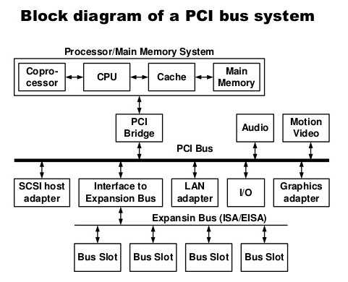
We can understand working of PCI through Plug and Play (PnP) as it utilizes the same concept.
- Once a new device has been inserted into a PCI slot on the motherboard.
- Operating System Basic Input/ Output System (BIOS) initiates “Plug and Play” (PnP) BIOS.
- PnP BIOS scans the PCI bus for any new hardware connected to the bus. If new hardware is found, it will ask for identification.
- The device will respond with its identification and send its device ID to the BIOS through the bus.
- PnP checks the Extended System Configuration Data (ESCD) to make sure the configuration data already exists for the card. (If the card is new, then there will be no data for it.)
- PnP will assign an Interrupt Request Line, Direct Memory Access, memory address and Input/ Output settings to the card, then stores the information in the ESCD.
- When the Windows software loads, it will check the PCI bus and the ESCD to see if there is new hardware. Windows will alert the user that new hardware has been found if there is new hardware installed and will also identify the hardware.
- Windows will determine the device and attempt to install its driver. The operating system may ask the user to insert a disk containing the driver or direct it to where the driver is located. In the event that Windows is unable to determine what the device is, it will provide a dialog window so the user can identify the hardware and load its driver.

Another example to understand how PCI works: Sound Card.
- The sound card will convert the analog signal to a digital signal.
- The digital audio data carried across the PCI bus to the bus controller, which determines which device on the PCI device has the priority to send data to the central processing unit (CPU) and whether the data will go directly to the CPU or to the system memory.
- If the sound card is in recording mode, the bus controller will assign a high priority to the data coming from the sound card. It will send the sound cards data over the bus bridge to the system bus.
- The system bus will save the data in system memory. When the recording is complete, then it will be up to the user to save the data from the sound card on either the hard drive, or will remain in memory for additional processing.
Other types of PCI:
- Original PCI
- PCI 2.3
- PCI-X
  - PCI-X 2.0 (second revision)
- PCI Express
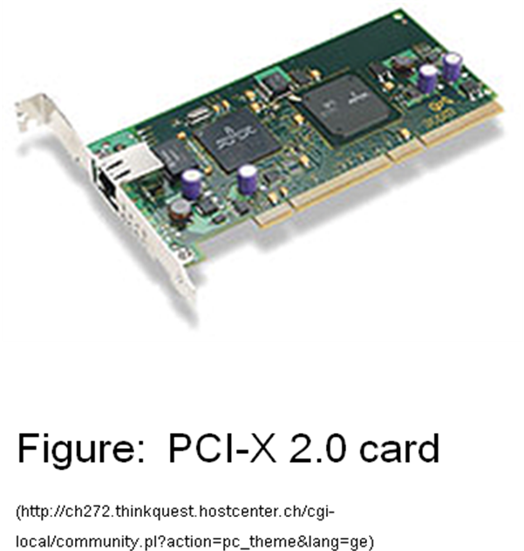

SCSI bus:
SCSI stands for Small Computer System Interface. It is pronounced as "Scuzzy" and is one of the most commonly used interface for disk drives that was first completed in 1982 by American National Standards Institute (ANSI). Unlike competing standards, SCSI is capable of supporting eight devices, or sixteen devices with Wide SCSI. However, with the SCSI host adapter located on ID number 07 and boots from the ID 00. This leaves the availability of six device connections. Once installed in the computer this adapter would allow multiple SCSI devices to be installed in the computer. More advanced motherboard may also have available SCSI connections on the motherboard. The types of SCSI include:
- SCSI-1 is the original SCSI standard developed back in 1986 as ANSI X3.131-1986. SCSI-1 is capable of transferring up to eight bits a second.
- SCSI-2 was approved in 1990, added new features such as Fast and Wide SCSI, and support for additional devices.
- SCSI-3 was approved in 1996 as ANSI X3.270-1996.
SCSI is a standard for parallel interfaces that transfers information at a rate of eight bits per second and faster, which is faster than the average parallel interface. SCSI-2 and above supports up to seven peripheral devices, such as a hard drive, CD-ROM, and scanner, that can attach to a single SCSI port on a system's bus. SCSI ports were designed for Apple Macintosh and Unix computers, but also can be used with PCs. Although SCSI has been popular in the past, today many users are switching over to SATA drives.
SCSI is used to increase performance, deliver faster data transfer transmission and provide larger expansion for devices such as CD-ROM drives, scanners, DVD drives and CD writers. SCSI is also frequently used with RAID, servers, high-performance PCs and storage area networks SCSI has a controller in charge of transferring data between the devices and the SCSI bus. It is either embedded on the motherboard or a host adapter is inserted into an expansion slot on the motherboard. The controller also contains SCSI basic input/output system, which is a small chip providing the required software to access and control devices. Each device on a parallel SCSI bus must be assigned a number between 0 and 7 on a narrow bus or 0 and 15 on a wider bus. This number is called an SCSI ID. Newer serial SCSI IDs such as serial attached SCSI (SAS) use an automatic process assigning a 7-bit number with the use of serial storage architecture initiators.
On an SCSI bus, each possible pair of devices can communicate. Whether their function allows this is another matter, but the standard does not restrict it.

The main phases involved in the operation of the SCSI bus are:
- Arbitration
- Selection
- Information Transfer
- Reselection

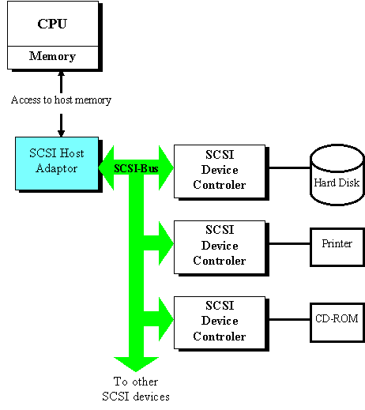
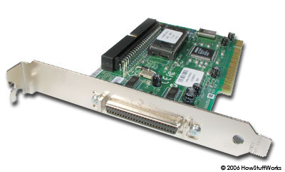

Conclusion: The aim of the experiment has been achieved.

Post Lab Descriptive Questions (Add questions from examination point view)

Q1. Differentiate between PCI and SCSI Bus.

PCI Bus | SCSI Bus
PCI stands for Peripheral Component Interconnect. | SCSI stands for Small Computer System Interface.
Developed by Intel in 1992. | Developed by ANSI in 1982.
PCI is a standard that describes how to connect peripheral components of a system together in a structured and controlled way. | SCSI allows personal computers to communicate with peripheral hardware such as printer, scanner, disk drives, etc.
It has a parallel system of data transmission (except PCIe which is series). | It has both series and parallel system of data transmission.
Transfer rate is around 2.5 GB/s (PCIe). | Transfer rate is around 4 GB/s (iSCSI over InfiniBand).

Q2. List the application of PCI and SCSI Bus.

A2. Applications of PCI bus:
- Used in sound cards, network cards, etc.
- Plug and play feature utilizes the concept of PCI.
- Useful in high quality live streaming and image/video processing.

Applications of SCSI bus:
- SCSI is used to connect peripherals to a computer.
- Used for connecting hard disks, tape devices, CD-ROMs, scanners, printers and many other devices to PC.
- SCSI is mostly used in server nowadays and in computers which require a very good performance.

Date: 18/07/2018 Signature of faculty in-charge

